Data communication are the exchange of data between to devices via some form of transmission medium such as a wire cable.

Effectiveness of data communication depends upon four fundamental characteristics:
–Delivery: The system must deliver data to the correct destination. Data must be received by the intended device or user.
–Accuracy: the system must deliver data accurately. Data that have been altered in transmission and left uncorrected are unusable.
–Timeliness: the system must deliver data in timely manner. Data deliver late are unusable. in the same order that they are produced, and without significant delay. This king of delivery is called real-time transmission.
–Jitter: Jitter refers to the variation in the packet arrival time. It is the uneven delay in the delivery of audio and video packets.

Component of data communication
–Message: The message is the information to be communicated. Popular forms of information include text, numbers, pictures, audio and video.
–Sender: the sender is device that sends the data message. It can be a computer, workstation, telephone handset, video camera, and so on.
–Receiver: The receiver is the device that receives the message. It can be a computer, workstation, telephone handset, video camera, and so on.
–Transmission Medium: The transmission is the physical path by which a message travels from sender to receiver. Ex. twisted pair, coaxial cable, fiber-optic cable, and radio waves.
–Protocol: A protocol is a set of rules that govern data communications. It represents an agreement between the communicating devices.

Simplex
Half Duplex
Full Duplex
Node: Computer, printer or any dives capable of sending or receiving data.
Computer Network: collection of autonomous(work independent) computer that are interconnected with each other or exchanging information with each other.
Network Criteria:
•Distributed Processing:
–In which task is divided among multiple computers.
–Instead of one single large machine is responsible for all, separate handle a subset.
•Performance:
–Measure is two way transit time and response time.
–Transit time: Amount of time required for a message to travel from one device to another.
–Response time: Elapsed time between an inquiry and response.
–It depends upon number of users, type of transmission medium, capacity of connected h/w, efficiency of s/w.
–It is evaluated by throughput and delay.
•Reliability measured by:
–Frequency of failure
–Time it takes a link to recover from failure
•Security:
–Protecting data from unauthorized access
–Protecting data from damage and development
–Implement procedures for recovery.

Topology
–The way in which the connections are made (shape of network) is called topology of network.
Network topology
–Refers to physical layout of the network, the location of the computer and how cable is run between them.

ISO standard that covers all aspects of network communications is the OSI model.
An open system is a set of protocols that allows any two different systems to communicate regardless architecture (hardware/software).
•The purpose of OSI model is to show how to facilitate communication between different system without requiring changes to the logic of the underlying hardware and software.
•OSI model is layered framework for design of network systems that allows communication between all types of computer system.
•It consist of 7 separate but related layers.

Physical Layer
•The physical layer is responsible for movement of individual bits from one hop (node) to the next.
It concerned with the following (responsibilities):

–Physical characteristics of interfaces and medium:
•Define the characteristics of the interface between device and transmission medium.
•Define type of transmission medium.
–Representation of bits:
•Data consist of a stream of bits (sequence 0 or 1)
•Bit must be encoded into signal (electrical or optical)
Data Rate:
•Number of bit sent each second is called transmission rate
–Synchronization of bit:
•Sender and receiver clock must be synchronized used same bit rate.
–Line configuration
•Concerned with connection of device
–Point – to – point : dedicated link
–Multipoint: link is shared among several device
–Physical topology:
•Define how device are connected in network
–Bus, ring, mesh, star, hybrid
–Transmission mode:
•Define the direction of transmission between two device
–Simples, half duplex and full duplex

Data Link Layer
•It is responsible for moving frames from one hop to next hop.
•It concerned with following responsibilities:
–Framing:
•Divides the stream of bits received from the network layer into manageable data units called Frame.
–Physical addressing
•Adds header to frame to define the sender and/or receiver.
Flow control
•Imposes a flow control mechanism to avoid overwhelming the receiver (rate at which data are absorbed by receiver is less than the rate of data produced in the sender).
–Error control
•Adds reliability to the physical layer: by adding mechanism to detect and retransmit damage or lost frames.
•Uses a mechanism to organize duplicate frames.
•Achieve through a trailer added to the end of frame.
–Access control
•Two or more devices are connected to the same link, data link layer protocol are necessary to determine which device has control over the link at time.
Network Layer
•Network layer is responsible for the delivery of individual packets from the source to destination. •The network layer is responsible for the delivery of packets from the source to destination.
•Data link layer oversees the delivery of the packet between two system on the same network, the network layer ensure that each packet gets from its point of origin to its final destination.

Responsibility
–Logical addressing
•Adds a header to the packet coming from the upper layer, includes the logical addresses of the sender and receiver.
–Routing
•One of the functions of network layer provides the mechanism to route or switch the packets to their final destinations.
•In internetwork or large network the connecting device is called router or switch.

Transport Layer
•The transport layer is responsible for the delivery of a message from one process to another.
Responsibility
–Service point addressing
•Header include service point address or port address.
•Gets the entire message to the correct process to the computer.
–Segmentation and reassembly
•A message is divided into transmittable segments, with unique sequence number.

–Connection control
•Layer can be connection less or connection oriented.
–Flow control
•End to end rather than across a single link.
–Error control
•Process to process rather than single link
•Error correction is achieved through retransmission.

Session Layer
•The session layer is responsible for dialog control and synchronization.
Responsibility
–Dialog control
•Allows two system to enter into a dialog: allows the communication between two processes to take place in either half-duplex or full-duplex.
Synchronization
–Allows a process to add checkpoints, or synchronization points to a stream of data.

Presentation Layer
•The presentation layer is responsible for translation, compression and encryption.
•Concerned with syntax and semantics of the information exchanged between two system.
•Responsibility
–Translation
•Different computers use different encoding system, the layer is responsible for interoperability between different encoding method.
•At sender changes information from its sender dependent format into common format, at receiver changes the common format into its receiver dependent format.
–Encryption
•A system must be able to ensure privacy to carry sensitive information.
•Encryption: sender transforms the original information to another form and pass message over network.
•Decryption: reverses the original process to transform the message back to its original form
–Compression:
•Data compression reduces the number of bits contain in the information.
•Important in the transmission of multimedia such as text, audio, video.

Application Layer
•The application layer is responsible for providing services to the user.
•Responsibility
–Network Virtual Terminal
•Network virtual terminal is a software version of a physical terminal, and it allow user to log on to a remote host, for that the application creates a software emulation of a terminal at a remote host.
–Mail Services
•Provides the basis for email forwarding and storage.
–File transfer, access and management
•Allows a user to access file in remote host, to retrieve files from a remote computer for use in local computer, and to manage a control files in a remote computer locally.
–Directory services
•Provides distributed database sources and access for global information about various objects and services.

TCP/IP
•TCP/IP protocol suits was developed prior to the OSI model.
•It have 4 layers
–Host – to – network
–Internet
–Transport
–Application

OSI vs TCP/IP
•Similarity :
–Both have layers.
–Both have application layer though they include very different services.
–Both have comparable transport and network layers.
–Both assumes packets are switched. This means that individual packets may take different path to reach same destination.
•Difference:
–TCP/IP combines the presentation and session layer issues into its application layer.
–TCP/IP combines the OSI data link and physical layers into the network access layer.
–TCP/IP appears simple because it has fewer layers.
–TCP/IP protocols are the standards around which the internet developed, so the TCP/IP model gains credibility just because of its protocol.

Key elements of protocol:
–Syntax: structure or format of data
–Semantics: meaning of each section in the structure.
–Timing: when and how fast data should be send.
Standards
Two categories:
–De Jure (“by law” or “by Regulation”) standards
–De Fecto (“by fact” or “by convention”) standards
•Proprietary standards: Closed standards
•Nonproprietary standards: Open standards

Advantage of fiber optic
–High bandwidth
•Fiber optic provide higher bandwidth than twisted pair & coaxial cable.
–Less Signal attenuation
•Transmission distance is grater than that of other guided media
•In twisted pair repeaters are required at every 5KM.
•While in fiber optic repeaters are required at every 50KM.
–Immunity to electromagnetic interference
•Electromagnetic noise cannot affect fiber optic cable
–Resistance to corrosive material
•Resistance power is more than copper cable
–Light weight
•Much lighter than copper
–Grater immunity to tapping
•Intruder can not tape fiber optic cable
•Disadvantage
–Installation and maintenance
•New technology so that expert engineer is required
–Unidirectional light propagation
•If we need bidirectional line than two fibers are needed
–Cost
•Cable and interfaces are relatively more expencive

Parity Bits
LRC
Checksum
CRC
Byte Stuffing
Framing techniques
–Character oriented approach
•Character count
•Byte stuffing
–Bit oriented approach
•Bit stuffing
Character Count
•Header: carries the source and destination address and other control information.
•Trailer: which carries error detection and error correction redundant bits, are multiples of 8 bits.
•Flag: flag is added at beginning and ending of the frame to separate one frame from the next.
–The flag composed of protocol dependent special character that signals the start or end of the frame.
•Problem with character count
–It is popular when only text was exchanged by the data link layer.
–This technique is not used, if we send other types of information such as graph, audio and video.
–For that byte stuffing strategy was added with character count framing.

Bit Stuffing
•Bit stuffing is the process of adding one extra 0 whenever five consecutive 1s follow a 0 in the data, so that the receiver does not mistake the pattern 0111110 for a flag.

Flow control refers to a set of procedures used to restrict the amount of data that the sender can send before waiting for acknowledgment.
Error control in the data link layer is based on automatic repeat request, which is the retransmission of data.
Protocols
Noisless Channel
Simplest
Stop and Wait
Noisy Channel
Stop and wait ARQ
Go back N Arq
Selective Repeat ARQ
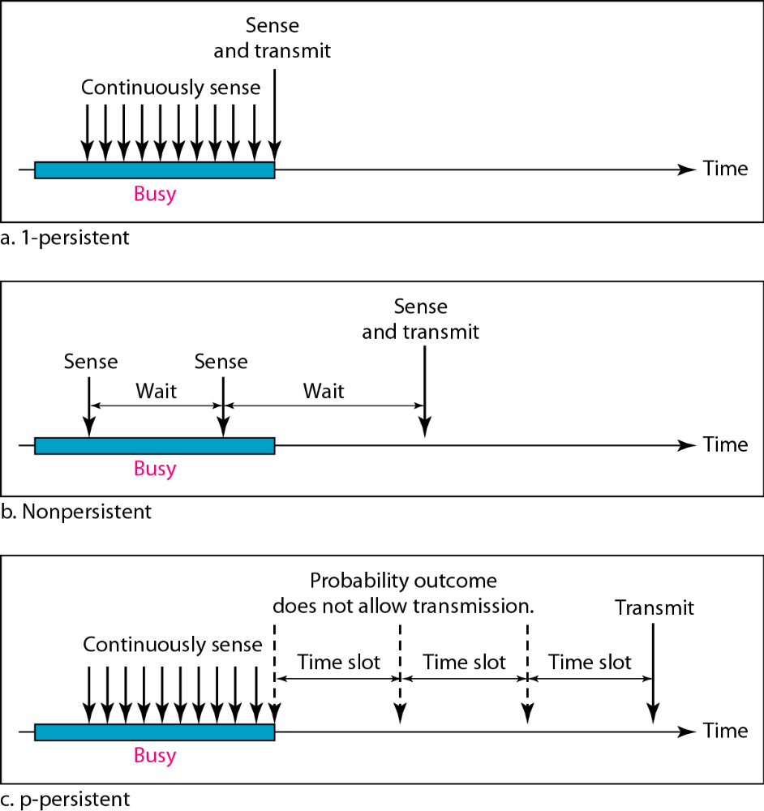

3)Ethernet
LLC- Logical Link Control
–Data link control handles framing, flow control and error control.
–In IEEE project 802, flow control, error control and part of the framing duties are collected into one sublayer called LLC.
–Framing is handle by both LLC and MAC.

LLC provides one single data link control protocol for all IEEE LANs. MAC provides different protocols for different LANs.
A single LLC protocol can provide interconnectivity between different LANs because it makes the MAC sublayer transparent..

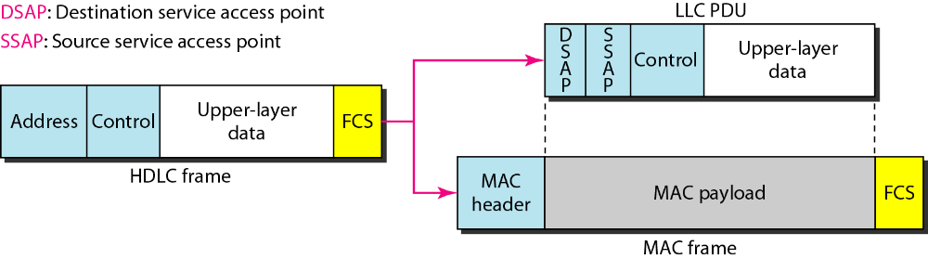

Need for LLC
–The purpose of the LLC is to provide flow and error for the upper layer protocol.
–Example: If a LAN or several LANs are used in isolated system.
•LLC may be needed to provide flow and error control for the application layer protocols.

Media Access Control
–It defines the specific access method for each LAN.
–Part of framing function is also handled by the MAC layer.

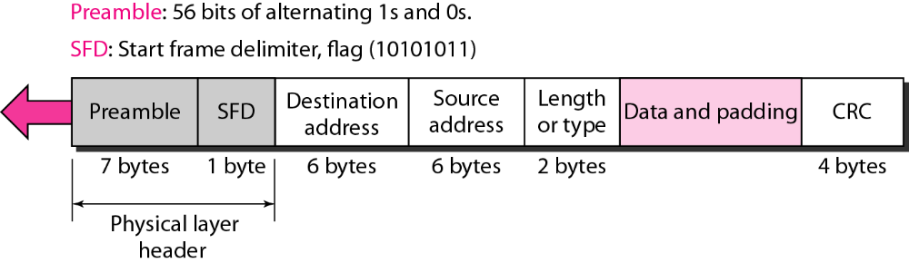
Show how the address 47:20:1B:2E:08:EE is sent out on line.
The address is sent left-to-right, byte by byte; for each byte, it is sent right-to-left, bit by bit, as shown below:
Goals of Fast Ethernet
–Upgrade the data rate to 100 Mbps.
–Make it compatible with standard Ethernet.
–Keep the same 48-bit address.
–Keep the same frame format.
–Keep the same minimum and maximum lengths.
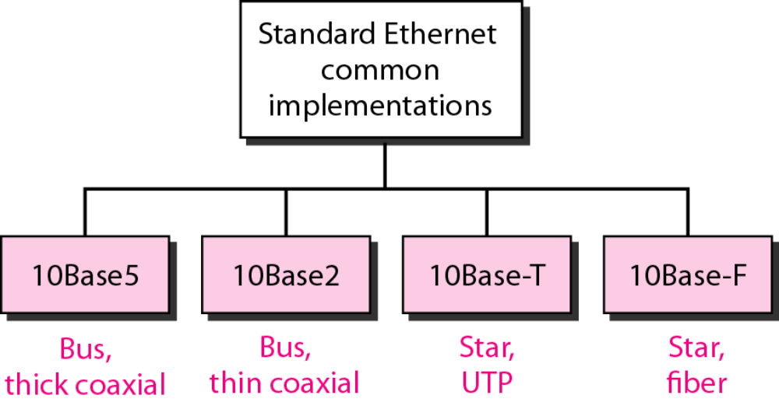

Half Duplex | Full Duplex
Stations are connected via hub. | The connection is made via switch with buffers  at each port.
The access method is same (CSMA/CD) for half duplex approach. | For full duplex fast Ethernet, there is no need  for CSMA/Cd.

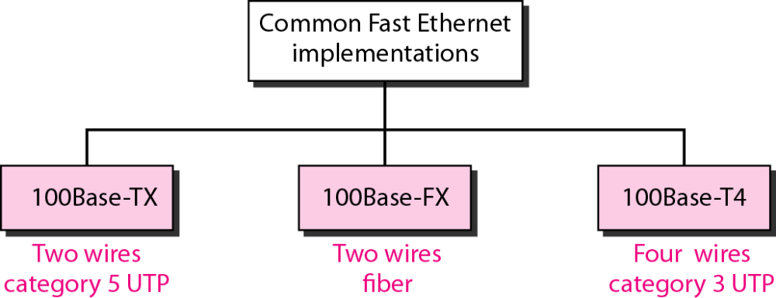
Gigabit Ethernet
•The need for an even higher data rate resulted in the design of the Gigabit Ethernet protocol (1000 Mbps).
•The IEEE committee calls the standard 802.3z.
•Goal :
–Upgrade data rate to 1 Gbps.
–Make it compatible with standard or Fast Ethernet.
–Use same 48 bit address.
–Use same frame format.
–Keep same maximum and minimum frame length.
–To support Autonegotiation as defined in Fast Ethernet.
•MAC Sublayer
•Gigabit Ethernet has 2 distinctive approach for medium access:
–Half duplex
–Full duplex.
•Almost all implementation of gigabit follows full duplex mode.
•Half duplex approach to show that gigabit Ethernet can be compatible with the previous generation

